

**HIGH LEVEL DESIGN (HLD) SIGN-OFF**

**Authorization Memorandum**

This form is to sign-off completion of the Design Phase for **CAMPUS MANAGEMENT SOFTWARE AT WORLD SKILL CENTER (WSC).**

World Skill Centre (WSC) acknowledges receipt of the deliverables as part of the Design Phase through the submission of this document.

|  |  |
| --- | --- |
| **MODULE NAME** | **Infrastructure: Project Plan Monitoring module** |
| **MODULE OWNER** | **Mr. Sanjay Padhi** |

**WSC AUTHORITY NAME AND SIGNATURE**

**SOUL AUTHORITY NAME AND SIGNATURE**

**High Level Design (HLD)**

Of

**Project Plan Monitoring module**

For Implementation of

**Campus Management Software**

at

**World Skill Center (WSC)**

**Sustainable Outreach And Universal**

**Leadership (SOUL) Limited**

**Confidentiality**

This document is a strictly confidential communication to and solely for the use of the recipient and may not be reproduced or circulated without SOUL Ltd’s prior written consent. If you are not the intended recipient, you may not disclose or use the information in this documentation in any way

**Document Control History**

|  |  |  |  |  |  |
| --- | --- | --- | --- | --- | --- |
| **Date** | **Version No.** | **Created By** | **Affected Sections** | **Reviewed By** | **Updated By** |
| 18-July-2023 | 1.0 | Subhodeep Dey | All |  |  |
| 20-July-2023 | 1.1 |  | Section 1.1, 1.2, 1.3, 1.6, 2.3.3,Design workflow,Project control,Section 8, Section2 | Sharmistha Panda |  |
| 21-July-2023 | 1.2 |  | Design workflow, notifications |  | Subhodeep Dey |

# Project Control

|  |  |
| --- | --- |
| **Package Number:** | PKG 0111 |
| **Project Name:** | Campus Management Software At World Skill Center (WSC) |
| **Location:** | Bhubaneswar |
| **Customer Name:** | World Skill Center (WSC) |
| **Customer Contact Information:** | Mancheswar, Bhubaneswar |
| **Project Manager / Email ID:** | Sharmistha Panda  sharmistha.panda@soulunileaders.com |
| **Module SME / Email ID:** | Mr. Sanjay Padhi  sanjay.padhi@worldskillcenter.org |

Table Of Contents

HIGH LEVEL DESIGN (HLD) SIGN-OFF 1

Authorization Memorandum 1

Project Control 3

1 Introduction 6

1.1 Background 6

1.2 Scope and Purpose of the document 6

1.3 Assumptions 7

1.4 Dependencies 7

1.5 Current IT Environment 7

1.6 Document Structure 7

1.7 Required System Architecture 7

1.8 Interoperability Framework 8

1.9 Technical Decision Summary 9

1.10 Architectural Risks & Mitigation 9

1.11 Reference 10

2 Enterprise Architecture Framework (Business Architecture) 10

2.1 Business Drivers 10

2.2 Business Concerns 10

2.3 Business Goals 10

2.4 Business Value Chain 10

2.5 Business Context Diagram 11

2.6 Business Process Flow 11

2.6.1 Project Plan and Monitoring 11

2.6.2 System Context Diagram 12

2.7 Conceptual Architecture 12

3 Architecture Views 13

3.1 Project 13

3.1.1 Use Case Diagram 13

3.1.2 Design Workflow 14

3.1.3 Validations 14

3.1.4 Field List: 15

3.1.5 Processes After Form Submission 16

3.1.6 Process Flow: 16

3.1.7 Pre-requisites and Dependency 17

3.2 Task 17

3.2.1 Use Case Diagram 17

3.2.2 Design Workflow 18

3.2.3 Validations 18

3.2.4 Field List: 19

3.2.5 Processes After Form Submission 20

3.2.6 Process Flow: 20

3.2.7 Pre-requisites and Dependency 20

3.3 Project Template 20

3.3.1 Use Case Diagram 20

3.3.2 Design Workflow 21

3.3.3 Validations 21

3.3.4 Field List: 21

3.3.5 Processes After Form Submission 22

3.3.6 Process Flow: 22

3.3.7 Pre-requisites and Dependency 22

3.4 Project Type 23

3.4.1 Use Case Diagram 23

3.4.2 Design Workflow 23

3.4.3 Validations 23

3.4.4 Field List: 24

3.4.5 Processes After Form Submission 24

3.4.6 Process Flow: 24

3.4.7 Pre-requisites and Dependency 25

3.5 Issue 25

3.5.1 Use Case Diagram 25

3.5.2 Design Workflow 25

3.5.3 Validations 25

3.5.4 Field List: 26

3.5.5 Processes After Form Submission 26

3.5.6 Process Flow: 26

3.5.7 Pre-requisites and Dependency 27

3.6 Issue Type 27

3.6.1 Use Case Diagram 27

3.6.2 Design Workflow 28

3.6.3 Validations 28

3.6.4 Field List: 29

3.6.5 Processes After Form Submission 29

3.6.6 Process Flow: 29

3.6.7 Pre-requisites and Dependency 29

3.7 Project Update 29

3.7.1 Use Case Diagram 30

3.7.2 Design Workflow 30

3.7.3 Validations 30

3.7.4 Field List: 31

3.7.5 Processes After Form Submission 31

3.7.6 Process Flow: 31

3.7.7 Pre-requisites and Dependency 31

4 Tools And Technologies 32

5 Non-Functional Requirements 32

5.1 Performance 32

5.2 Reliability 32

5.3 Usability 32

5.4 Compatibility 32

5.5 Security 32

5.6 Compliance 32

5.7 Documentation 32

5.8 Security: User access and authorization 32

Prototype 34

6 Prototype 35

6.1 Project 35

Figure : Project 35

6.2 Task 35

6.3 Project Template 36

6.4 Project Type 36

6.5 Issue 36

6.6 Issue Type 37

6.7 Project Update 37

7 Definitions and Acronyms 37

8 Deployment Description 38

# Introduction

The World Skill Center (WSC) is a premier advanced skill training institute established by the Government of Odisha, Skill Development and Technical Education Department, through the Odisha Skill Development Authority (OSDA). The WSC will impart advanced skill training in eight trades from engineering and service sectors. WSC caters primarily to induct the best talent from ITIs and Polytechnics and train them to become globally employable in emerging areas such as "Industry 4.0". WSC is housed in a state-of-the-art, 18-storey, air-conditioned building with nearly half a million square feet of space in the heart of capital city of Bhubaneswar.

With the implementation of campus management software for WSC the goal is to streamline the operations and functions of the campus by integrating various processes, such as admissions, course registration, academic progress tracking, and financial management, HRMS, Procurement and Inventory management, etc into a unified system. The implementation also aims at providing a user-friendly interface for all stakeholders, making it easier for them to access the necessary information and complete their tasks with ease. The modules to be covered during the implementation of the software include:

|  |  |
| --- | --- |
| Students Management Modules | Infrastructure Management |
| Academic System | Finance and Accounting System |
| Procurement & Inventory Management | Training and Placement |
| Human Resources Management System | Application Integration |

# 

## Background

The Web Based Campus Management Application at World Skill Centre (WSC) application is required by WSC for the smooth operation of all departments / support functions with on-line delivery of services to all stakeholders.

The project aims to create a mechanism to provide the basis for evolution of an IT enabled state of the art workflow automation system in a planned manner.

## Scope and Purpose of the document

The design documents track the necessary information required to effectively define architecture and system design in order to give the development team guidance on the architecture of the system to be developed. Its intended audience is the project manager, project team, and development team. Some portions of this document, such as the user interface (UI), may be shared with the client/user, and other stakeholders whose input/approval into the UI is needed.

This document covers all the design aspects of Project plan and monitoring of ERP Product. This module helps in organizing the projects and tasks. This module covers the need of an organization to track and update each of their processes to stay afloat and grow in the industry. The Project module helps an organization to keep track of such deliverable and ensure their timely completion.

The scope of Infrastructure - Project Plan and Monitoring Tool module

* **Database on ongoing Projects / Task**
* **Estimate preparation monitoring for new Project / Task**
* **Project Plan Monitoring**

## Assumptions

The assumptions are listed as follows:

* The hardware and software requirements will be provided as specified
* Data loading to be handled by WSC
* All external entities will provide their interface for application integration

## Dependencies

The ERP system will be dependant on external interfaces for integration services. Following are few external interfaces:

* Payment Gateway
* Communication channels such as – Email, SMS, WhatsApp
* Microsoft 365
* Biometric System
* Website

## Current IT Environment

|  |  |
| --- | --- |
| **Hardware Requirements** | **Software Requirements** |
| Processor: Intel CPU with at least 8 cores | Operating System: Ubuntu 22.04 LTS |
| RAM: 16 GB to 32 GB | Web Server: Nginx |
| Storage: A minimum of 160 GB SSD | Database server: MariaDB |
| Network: 1 Gbps | Python: 3.10 or later |

## Document Structure

The following sections are part of this document :

* Business goals, objectives and requirements
* Understand business context and interactions
* Conceptual design
* Overall system context
* Understand use-case and scenarios
* Define implementation

## Required System Architecture

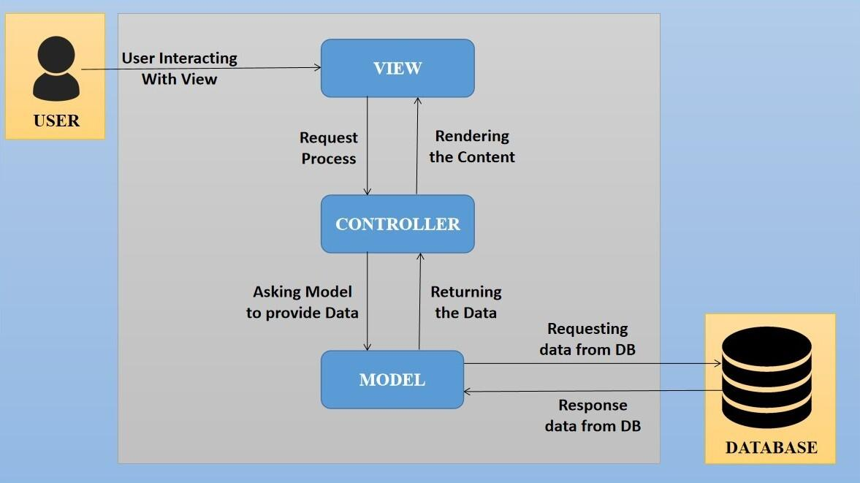

The proposed design is an architectural pattern that separates an application into three main logical

components: The **Model**, the **View** and the **Controller**. Each of these components are built to handle

specific development aspects of the application like:

* The Model component corresponds to all the data-related logic that the user works with. This can represent either the data that is being transferred between the View and Controller components or any other business logic-related data
* The View component is used for all the UI logic of the application. It generates a user interface for the user
* The controller is the component that enables the interconnection between the views and the model so it acts as an intermediary

## Interoperability Framework

Frappe is a full stack, batteries-included, web framework written in Python and JavaScript with MariaDB as the database. It is pretty generic and can be used to build database-driven apps with an elegant and consistent UI.

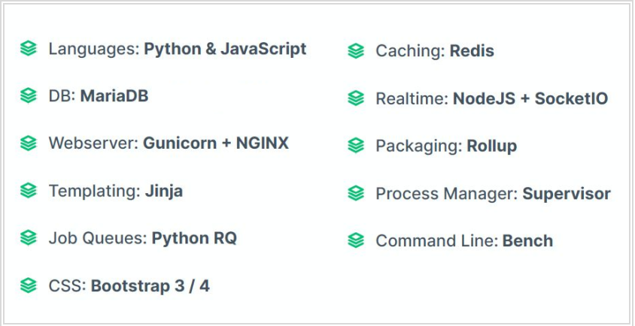

## Technical Decision Summary

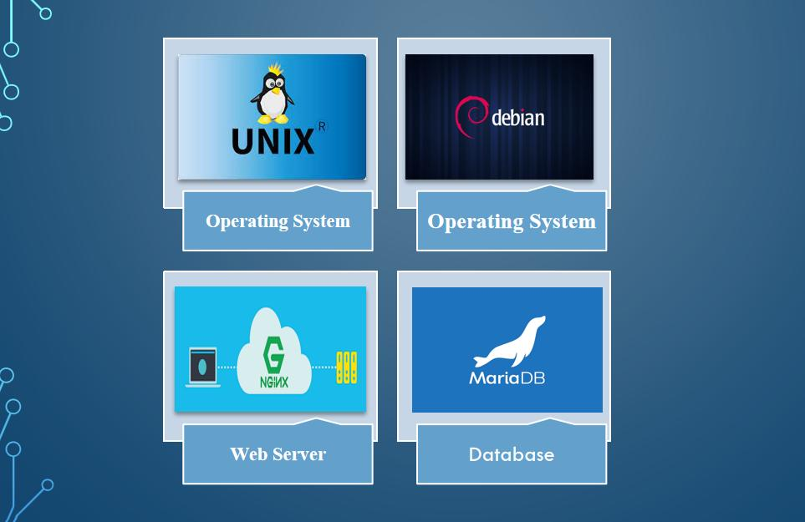

## Architectural Risks & Mitigation

|  |  |
| --- | --- |
| **Risks** | **Recommendation** |
| Inability to provide the required hardware resources (Server) for installation of the ERP product | The issue should be brought up during cadence meetings, and the OCAC/WSC IT team should assure timely availability of the required server |
| Unavailability of API for third party integration | The project timeline schedule needs to be shared with third parties to avoid the delay in integration. Also, inclusion of external teams to meet timelines |

## Reference

|  |  |
| --- | --- |
| ***Sl No.*** | ***Document Name*** |
| 1 | SRS for Infrastructure Project Plan and Monitoring |
|  |  |

# Enterprise Architecture Framework (Business Architecture)

## Business Drivers

The following points motivate the business efficacy of Campus Management Software at World Skill Center (WSC) system:

* Integrate the various functions such as Admission, Academics, Examination, Training & Placement, HRMS, Procurement, Finance into a single platform which can be customized as per user requirements
* Implement a common framework for the system and sub systems
* Provide web based application for the users to interact with the system with Role based Access and consistent look and feel

## Business Concerns

Campus Management Software At World Skill Center application is designed to address the following concerns:

Student Management: To help the students / trainers manage the students admission activities, starting from initial communication to course enrollment

Financial Management: Managing finances is a fundamental concern for businesses. This includes budgeting, cash flow management, ledger maintenance, balance sheet,etc

Employee Engagement: Attracting, retaining, and engaging skilled and motivated employees is critical. Human resources concerns also include training, performance management

Procurement management: The source-to-settle process. It encompasses the evaluation, selection, and creation of formal contractual agreements as well as managing the company's ongoing supplier relationships

## Business Goals

The goal is to implement a web based Campus Management Application System for efficient internal functioning of World Skill Center (WSC) with on-line delivery of services to each stakeholder of WSC supported by a suitable, robust, secure and reliable system

## Business Value Chain

The ERP system's business value chain typically encompasses the following key components:

Procurement Management: This includes the processes related to sourcing and acquiring raw materials, goods, or services required for the organization's operations. The ERP system streamlines procurement activities, such as supplier management, purchase requisitions, purchase orders, and inventory management, leading to cost savings and better supply chain management.

Production/Operations Management: The ERP system facilitates the planning, scheduling, and execution of production processes. It optimizes resource allocation, tracks work progress, manages bills of materials, and monitors production costs to enhance overall operational efficiency and quality.

Inventory Management: The ERP system enables real-time tracking of inventory levels, stock movements, and stock outs. It helps in maintaining optimal inventory levels, reducing carrying costs, and ensuring timely availability of products.

Financial Management: ERP systems centralize financial data and automate accounting, financial reporting, budgeting, and financial analysis. This streamlines financial processes, enhances accuracy, and provides management with a clear financial overview for better decision-making.

Human Resources Management: ERP systems handle various HR functions, including payroll, employee records, recruitment, performance management, and training. This leads to streamlined HR processes, improved workforce management, and enhanced employee satisfaction.

## Business Context Diagram

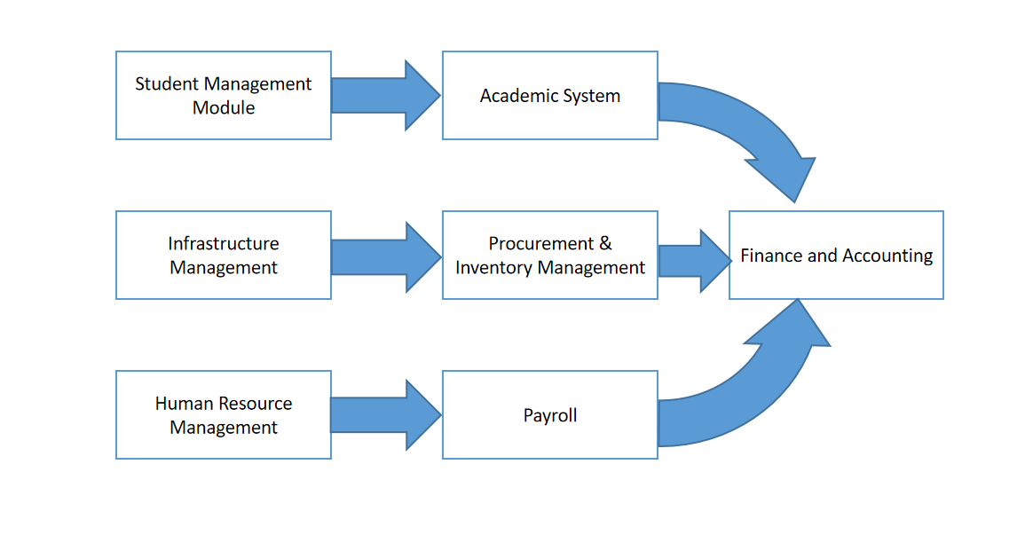

## Business Process Flow

### Project Plan and Monitoring

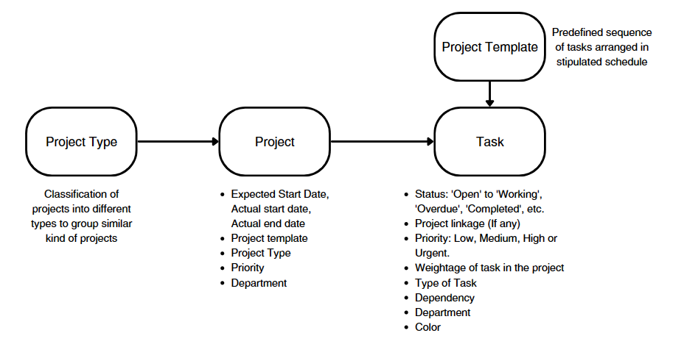

### System Context Diagram

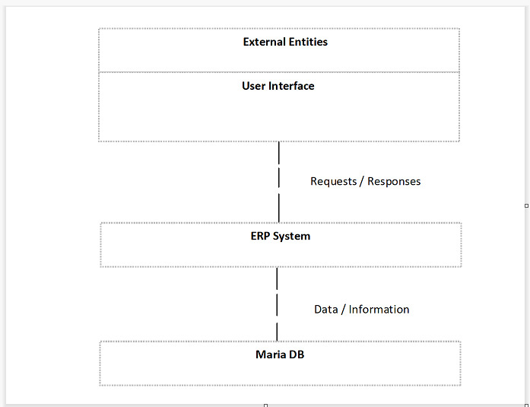

## Conceptual Architecture

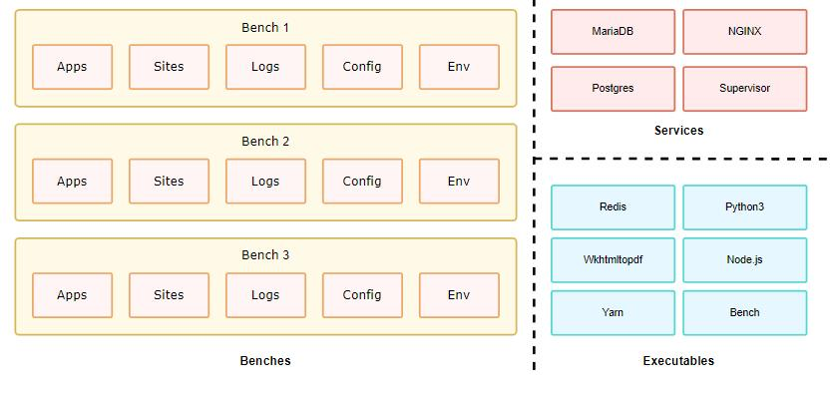

A single bench can host multiple combinations of sites and apps. For the most part, having a single bench works for hosting hundreds of sites that depend on the same versions of said app, given you've scaled up the workers. You can host multiple versions of the application on the same server by creating multiple benches parallelly. The following diagram hints to the system dependencies and how they are used.

# Architecture Views

## Project

A Project is a planned piece of work that is designed to find information about something, to produce something new, or to improve something.

In this module, project management is task-driven. You can create a Project and divide it into multiple Tasks.

A Project has a broad scope and hence can be divided into tasks. Think of coming up with a new smartphone for the next year as a Project. Then things like designing, prototyping, testing, delivery, etc. become tasks under the project.

### Use Case Diagram

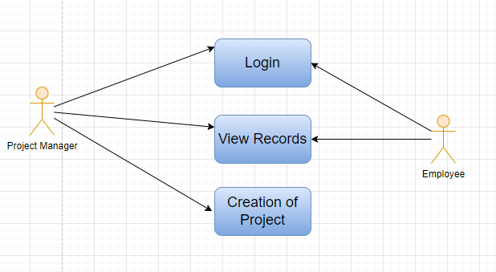

### 

### Design Workflow

* Design workflow is not applicable to this screen as records in this are created by only one role and are not sent to users with other roles for approval or modification.

### Validations

**Client Side Validation :**

Client-side validation refers to the process of validating user input directly on the client's web browser before saving it to the server for further processing.

The following validations are done on client side for Land Screen:

* Mandatory checks for fields : Project Name
* Linked Fields : The Project Type field is linked with the Project Screen. The From Template field is linked with the Project Template Screen. The Department field is linked with the Department Screen. The Customer field is linked with the Customer Screen. The Company field is linked with the Company Screen. The Holiday List field is linked with the Holiday List Screen.

**Server Side Validation :**

Server-side validation refers to the process of validating user input on the server to ensure data integrity, security, and adherence to business rules before accepting or processing the information.

No server side validation is done for Project Screen.

**Notification:**

* This section is not applicable since there is no notifications to be triggered

### Field List:

|  |  |  |  |  |  |
| --- | --- | --- | --- | --- | --- |
| **ID** | **Field Label** | **Field Type** | **Validation/Action** | **Mandatory** | **Remarks** |
| 1 | Project Name | Text Field | User Input | Y |  |
| 2 | Status | Dropdown | Open  Completed  Cancelled |  |  |
| 3 | Project Type | Link | Fetched from Project type screen |  |  |
| 4 | Is Active | Dropdown | Yes  No |  |  |
| 5 | % Complete Method | Dropdown | Manual  Task Completion  Task Progress  Task Weight |  |  |
| 6 | % Completed | Percent |  |  |  |
| 7 | From Template | Link | Fetched from Project Template screen |  |  |
| 8 | Expected Start Date | Date picker | User Input |  |  |
| 9 | Expected End Date | Date picker | User Input |  |  |
| 10 | Priority | Dropdown | Medium  Low  High |  |  |
| 11 | Department | Link | Fetched from Department screen |  |  |
| 12 | Customer | Link | Fetched from Customer screen |  |  |
| 13 | Sales Order | Link | Fetched from Sales Order screen |  |  |
| 14 | **Project User** | Table | Project User Table is described below |  |  |
| 15 | Copied From | Data |  |  |  |
| 16 | Notes | Text Editor | User Input |  |  |
| 17 | Actual Project Start Date | Date picker | User Input |  |  |
| 18 | Actual Project Time Hours | Number | User Input |  |  |
| 19 | Actual Project End Date | Date picker | User Input |  |  |
| 20 | Estimated Cost | Currency | User Input |  |  |
| 23 | Company | Link | Fetched from company screen |  |  |
| 24 | Collect Progress | Check box | User Input |  |  |
| 25 | Holiday List | Link | Fetched from Holiday List screen |  |  |
| 26 | Frequency To Collect Progress | Dropdown | Hourly  Twice Daily  Daily  Weekly |  |  |
| 27 | From Time | Time picker | User Input |  |  |
| 28 | To Time | Time picker | User Input |  |  |
| 29 | First Email | Time picker | User Input |  |  |
| 30 | Second Email | Time picker | User Input |  |  |
| 31 | Daily Time to send | Time picker | User Input |  |  |
| 32 | Day to Send | Dropdown | Monday  Tuesday  Wednesday  Thursday  Friday  Saturday  Sunday |  |  |
| 33 | Weekly Time to send | Time picker | User Input |  |  |
| 34 | Message | Text Field | User Input |  |  |

|  |  |  |  |  |  |
| --- | --- | --- | --- | --- | --- |
| **Project User** | | | | | |
| **ID** | **Field Label** | **Field Type** | **Validation/Action** | **Mandatory** | **Remarks** |
| 1 | User | Link | Fetched from User screen |  |  |
| 2 | Email | Read Only | Auto fetched Based on User Field |  |  |
| 3 | Image | Read Only | Auto fetched Based on User Field |  |  |
| 4 | Full Name | Read Only | Auto fetched Based on User Field |  |  |
| 5 | Welcome email sent | Check Box | User Input |  |  |
| 6 | View attachments | Check Box | User Input |  |  |
| 7 | Project Status | Text Field |  |  |  |

### Processes After Form Submission

* This section is not applicable since the form is not submittable.

### Process Flow:

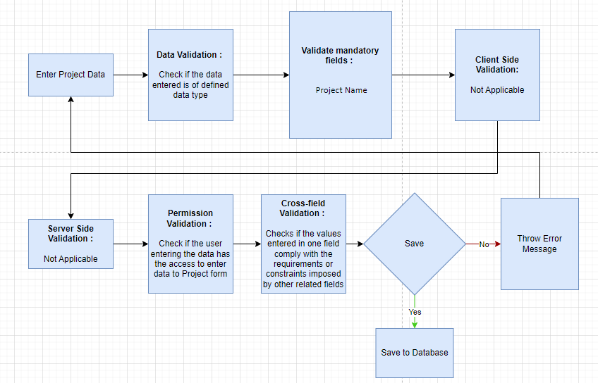

### Pre-requisites and Dependency

* Project Type
* Project template(if needed)

## Task

In project management, a task is an actionable unit or activity which needs to be completed. Whilst each task within a Project can be assigned to an individual or a group of individuals, the assignment can also be done at the project level.

These Tasks can be created from a Project itself or a Task can be created separately as well.

### Use Case Diagram

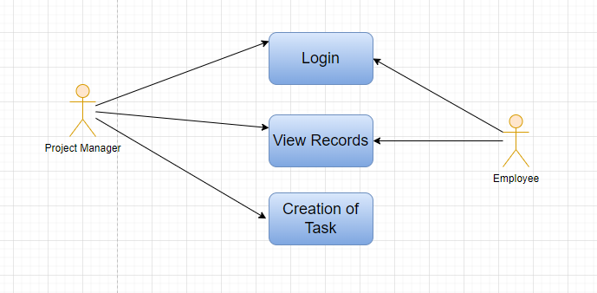

### Design Workflow

* Design workflow is not applicable to this screen as records in this are created by only one role and are not sent to users with other roles for approval or modification.

### Validations

**Client Side Validation:**

Client-side validation refers to the process of validating user input directly on the client's web browser before saving it to the server for further processing.

The following validations are done on client side for Building Screen:

* Mandatory checks for fields: Subject
* Linked Fields: The Project name field is linked with the Project Screen. The Issue field is linked with the Issue Screen. The Type field is linked with the Task Type Screen. The Parent Task field is linked with the Task Screen. The Completed By field is linked with the User Screen.

**Server Side Validation:**

Server-side validation refers to the process of validating user input on the server to ensure data integrity, security, and adherence to business rules before accepting or processing the information.

No server side validation is done for Task Screen.

**Notification:**

* This section is not applicable since there is no notifications to be triggered

### Field List:

|  |  |  |  |  |  |
| --- | --- | --- | --- | --- | --- |
| **ID** | **Field Label** | **Field Type** | **Validation/Action** | **Mandatory** | **Remarks** |
| 1 | Subject | Text Field | User Input | Y |  |
| 2 | Project | Link | Fetched from Project screen |  |  |
| 3 | Issue | Link | Fetched from Issue screen |  |  |
| 4 | Type | Link | Fetched from Task Type screen |  |  |
| 5 | Color | Color picker | User Input |  |  |
| 6 | Is Group | Check Box | User Input |  |  |
| 7 | Is Template | Check Box | User Input |  |  |
| 8 | Status | Drop down | Open  Working  Pending Review  Overdue  Template  Completed  Cancelled |  |  |
| 9 | Priority | Drop down | Low  Medium  High  Urgent |  |  |
| 10 | Weight | Number | User Input |  |  |
| 11 | Parent Task | Link | Fetched from Task screen |  |  |
| 12 | Completed By | Link | Fetched from User screen |  |  |
| 13 | Completed On | Date picker | User Input |  |  |
| 14 | Expected Start Date | Date picker | User Input |  |  |
| 15 | Expected Time (in hours) | Number | User Input |  |  |
| 16 | Begin On (Days) | Number | User Input |  |  |
| 17 | Expected End Date | Date picker | User Input |  |  |
| 18 | % Progress | Percent | User Input |  |  |
| 19 | Duration (Days) | Number | User Input |  |  |
| 20 | Is Milestone | Check Box | User Input |  |  |
| 21 | Task Description | Text Editor | User Input |  |  |
| 22 | **Task Depends On** | Table | Task Depends On Table is described below |  |  |
| 23 | Actual Task Start Date | Date picker | User Input |  |  |
| 24 | Actual Task Time Hours | Number | User Input |  |  |
| 25 | Actual Task End Date | Date picker | User Input |  |  |
| 28 | Review Date | Date picker | User Input |  |  |
| 29 | Closing Date | Date picker | User Input |  |  |
| 30 | Department | Link | Fetched from Department screen |  |  |
| 31 | Company | Link | Fetched from Company screen |  |  |

|  |  |  |  |  |  |
| --- | --- | --- | --- | --- | --- |
| **Task Depends On** | | | | | |
| **ID** | **Field Label** | **Field Type** | **Validation/Action** | **Mandatory** | **Remarks** |
| 1 | Task | Link | Fetched from Task screen |  |  |
| 2 | Subject | Text Field | User Input |  |  |
| 3 | Project | Text Field | User Input |  |  |

### Processes After Form Submission

* This section is not applicable since the form is not submittable.

### Process Flow:

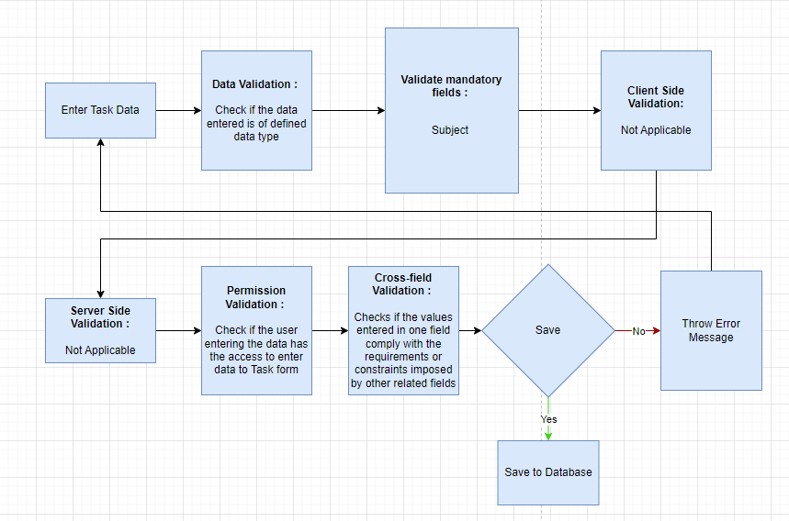

### Pre-requisites and Dependency

* Not Applicable

## Project Template

A Project Template is a predefined sequence of tasks arranged in stipulated schedule.

These templates can be pulled for similar kind of Projects and the tasks therein get auto-populated at the time of creation of each new project.

### Use Case Diagram

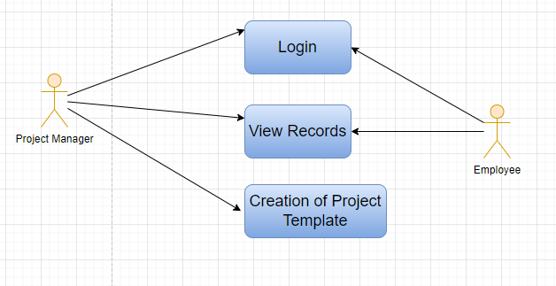

### Design Workflow

* Design workflow is not applicable to this screen as records in this are created by only one role and are not sent to users with other roles for approval or modification.

### Validations

**Client Side Validation:**

Client-side validation refers to the process of validating user input directly on the client's web browser before saving it to the server for further processing.

The following validations are done on client side for Floor Screen:

* Mandatory checks for fields : Project Template Task
* Linked fields : The Project Type field is linked with the Project Type Screen. The Task field is linked with the Task Screen.

**Server Side Validation:**

Server-side validation refers to the process of validating user input on the server to ensure data integrity, security, and adherence to business rules before accepting or processing the information.

No server side validation is done for Project Template Screen.

**Notification:**

* This section is not applicable since there is no notifications to be triggered

### Field List:

|  |  |  |  |  |  |
| --- | --- | --- | --- | --- | --- |
| **ID** | **Field Label** | **Field Type** | **Validation/Action** | **Mandatory** | **Remarks** |
| 1 | Name | Text Field | User Input |  |  |
| 2 | Project Type | Link | Fetched from Project Type screen |  |  |
| 3 | **Project Template Task** | Table | User Input | Y |  |

|  |  |  |  |  |  |
| --- | --- | --- | --- | --- | --- |
| **Project Template Task** | | | | | |
| **ID** | **Field Label** | **Field Type** | **Validation/Action** | **Mandatory** | **Remarks** |
| 1 | Task | Link | Fetched from Task screen | Y |  |
| 2 | Subject |  | Read Only |  |  |

### Processes After Form Submission

* This section is not applicable since the form is not submittable.

### Process Flow:

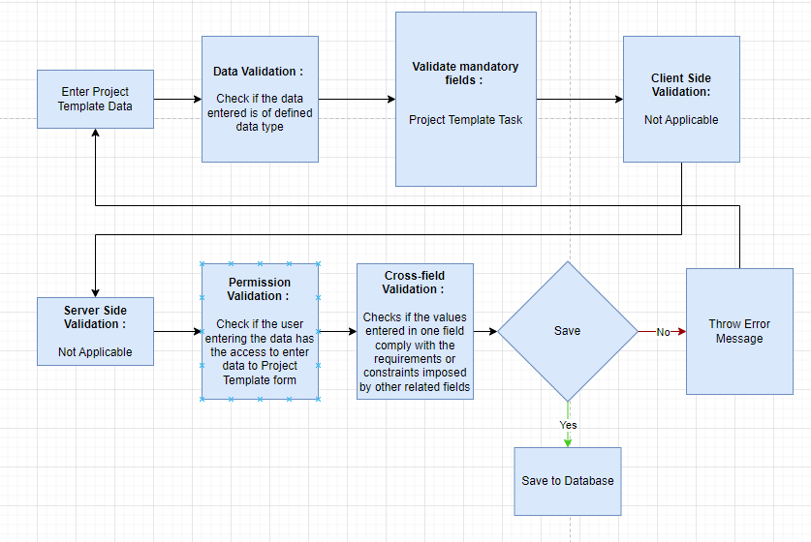

### Pre-requisites and Dependency

* Task

## Project Type

A Project Type is the classification of projects into different types to group similar kind of projects.

Internal Projects, External Projects could be examples of Project types and are already created in the system. You can choose to add more Project Types. This comes handy when you are reviewing the Projects, and you want to filter the information based on Project Types.

### Use Case Diagram

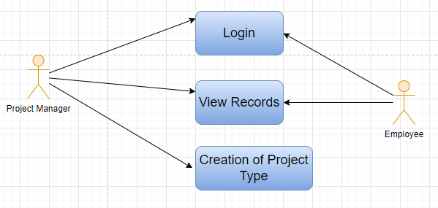

### Design Workflow

* Design workflow is not applicable to this screen as records in this are created by only one role and are not sent to users with other roles for approval or modification.

### Validations

**Client Side Validation:**

Client-side validation refers to the process of validating user input directly on the client's web browser before saving it to the server for further processing.

The following validations are done on client side for Building Room Screen:

* Mandatory checks for fields : Project Type
* Linked fields : Not Applicable

**Server Side Validation:**

Server-side validation refers to the process of validating user input on the server to ensure data integrity, security, and adherence to business rules before accepting or processing the information.

No server side validation is done for Project Type Screen.

**Notification:**

* This section is not applicable since there is no notifications to be triggered

### Field List:

|  |  |  |  |  |  |
| --- | --- | --- | --- | --- | --- |
| **ID** | **Field Label** | **Field Type** | **Validation/Action** | **Mandatory** | **Remarks** |
| 1 | Project Type | Text field | User Input | Y |  |
| 2 | Description | Text field | User Input |  |  |

### Processes After Form Submission

* This section is not applicable since the form is not submittable.

### Process Flow:

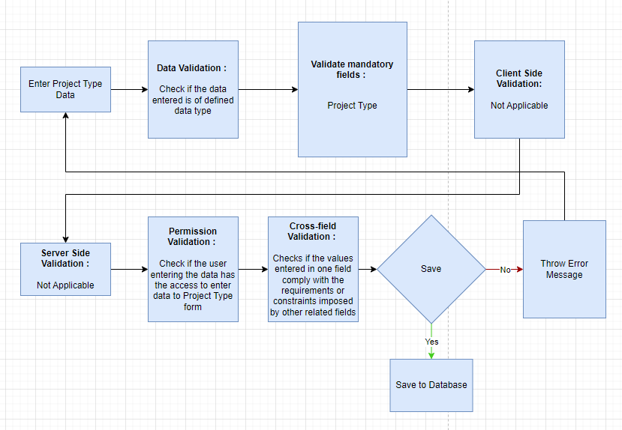

### Pre-requisites and Dependency

* Not Applicable

## Issue

This screen helps maintain issues which may come up in the project.

### Use Case Diagram

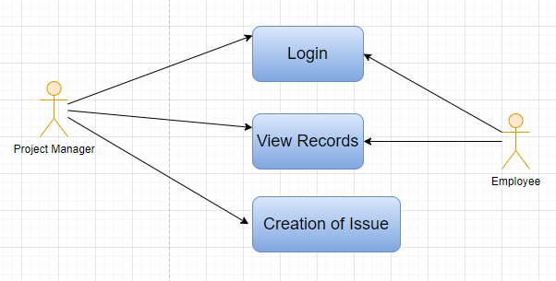

### Design Workflow

* Design workflow is not applicable to this screen as records in this are created by only one role and are not sent to users with other roles for approval or modification.

### Validations

**Client Side Validation:**

Client-side validation refers to the process of validating user input directly on the client's web browser before saving it to the server for further processing.

The following validations are done on client side for Building Type Room Screen:

* Mandatory checks for fields : Subject
* Linked fields : The Priority field is linked with the Priority Screen. The Issue Type field is linked with the Issue Type Screen. The Issue Split From field is linked with the Issue Split From Screen. The Project field is linked with the Project Screen.

**Server Side Validation:**

Server-side validation refers to the process of validating user input on the server to ensure data integrity, security, and adherence to business rules before accepting or processing the information.

No server side validation is done for Issue Screen.

**Notification:**

* This section is not applicable since there is no notifications to be triggered

### Field List:

|  |  |  |  |  |  |  |
| --- | --- | --- | --- | --- | --- | --- |
| **ID** | **Field Label** | **Field Type** | **Validation/Action** | **Mandatory** | **Remarks** | **R/N/D** |
| 1 | Subject | Text field | User Input | Y |  |  |
| 2 | Raised By | Text field | User Input |  |  |  |
| 3 | Status | Drop Down | Open  Replied  On Hold  Resolved  Closed |  |  |  |
| 4 | Priority | Link Field | Fetched from Issue priority screen |  |  |  |
| 5 | Issue Type | Link Field | Fetched from Issue Type screen |  |  |  |
| 6 | Issue Split From | Link Field | Fetched from Issue screen |  |  |  |
| 7 | Description | Text Editor | User Input |  |  |  |
| 8 | Project | Link Field | Fetched from Project screen |  |  |  |
| 9 | Attachment | Attach Button | User Input |  |  |  |

### Processes After Form Submission

* This section is not applicable since the form is not submittable.

### Process Flow:

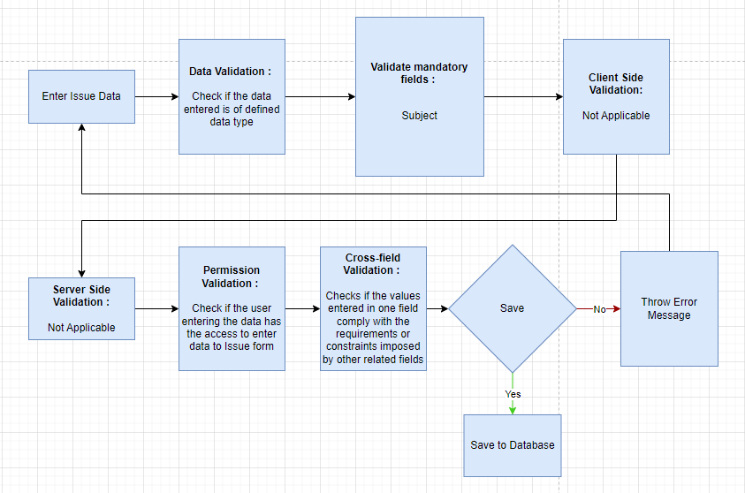

### Pre-requisites and Dependency

* Not Applicable

## Issue Type

Issue Type is useful for tagging and classifying Issues.

Classifying Issues helps in assigning the concerned team members to specific Issues. Examples of Issue Types can be: 'Functional', 'Technical', 'Hardware', etc. So engineers can be assigned to technical or hardware issues and consultants would be assigned to address functional issues.

### Use Case Diagram

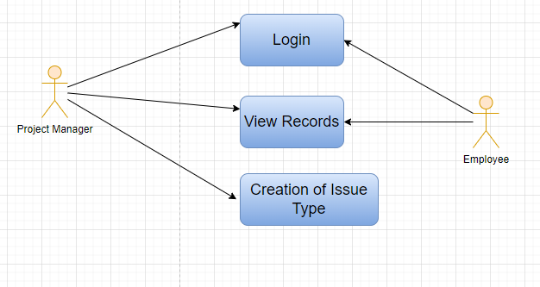

### Design Workflow

* Design workflow is not applicable to this screen as records in this are created by only one role and are not sent to users with other roles for approval or modification.

### Validations

**Client Side Validation:**

Client-side validation refers to the process of validating user input directly on the client's web browser before saving it to the server for further processing.

The following validations are done on client side for Asset Screen:

* Mandatory checks for fields : Name
* Linked fields : Not Applicable

**Server Side Validation:**

Server-side validation refers to the process of validating user input on the server to ensure data integrity, security, and adherence to business rules before accepting or processing the information.

No server side validation is done for Issue Type Screen.

**Notification:**

* This section is not applicable since there is no notifications to be triggered

### Field List:

|  |  |  |  |  |  |  |
| --- | --- | --- | --- | --- | --- | --- |
| **ID** | **Field Label** | **Field Type** | **Validation/Action** | **Mandatory** | **Remarks** | **R/N/D** |
| 1 | Name | Text field | User Input | Y |  |  |
| 2 | Description | Text field | User Input |  |  |  |

### Processes After Form Submission

* This section is not applicable since the form is not submittable.

### Process Flow:

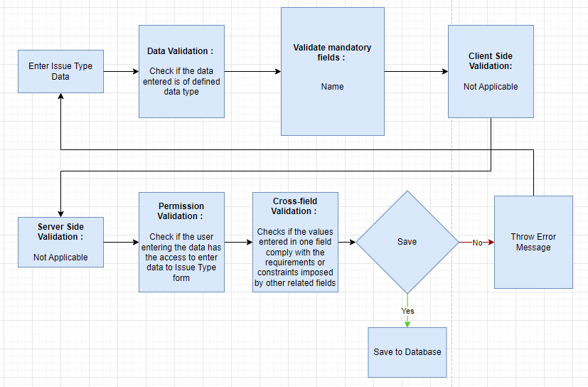

### Pre-requisites and Dependency

* Not Applicable

## Project Update

A Project Update is the status of the Project which can be sent to all the stakeholders of the Project.

Each time you want to update the stakeholders about the project, you can send a Project Update to them.

### Use Case Diagram

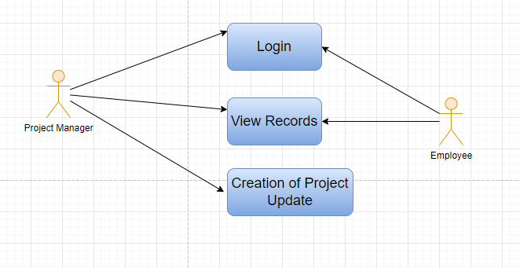

### Design Workflow

* Design workflow is not applicable to this screen as records in this are created by only one role and are not sent to users with other roles for approval or modification.

### Validations

**Client Side Validation:**

Client-side validation refers to the process of validating user input directly on the client's web browser before saving it to the server for further processing.

The following validations are done on client side for Asset Maintenance Team Screen:

* Mandatory checks for fields : Maintenance Team Name, Company, Maintenance Team Members
* Linked fields : The User field is linked with the User Screen.

**Server Side Validation:**

Server-side validation refers to the process of validating user input on the server to ensure data integrity, security, and adherence to business rules before accepting or processing the information.

No server side validation is done for Project Update Screen.

**Notification:**

* This section is not applicable since there is no notifications to be triggered

### Field List:

|  |  |  |  |  |  |  |
| --- | --- | --- | --- | --- | --- | --- |
| **Project User** | | | | | | |
| **ID** | **Field Label** | **Field Type** | **Validation/Action** | **Mandatory** | **Remarks** | **R/N/D** |
| 1 | User | Link field | Fetched from User screen | Y |  |  |
| 2 | Email | Text field | Read Only, Auto fetched |  |  |  |
| 3 | Full Name | Text field | Read Only, Auto fetched |  |  |  |
| 4 | Welcome email sent | Check box | Read Only, Auto fetched |  |  |  |
| 5 | View attachments | Check box | Project User |  |  |  |
| 6 | Project Status | Text field | User Input |  |  |  |

### Processes After Form Submission

* This section is not applicable since the form has no workflow based on submission.

### 

### Process Flow:

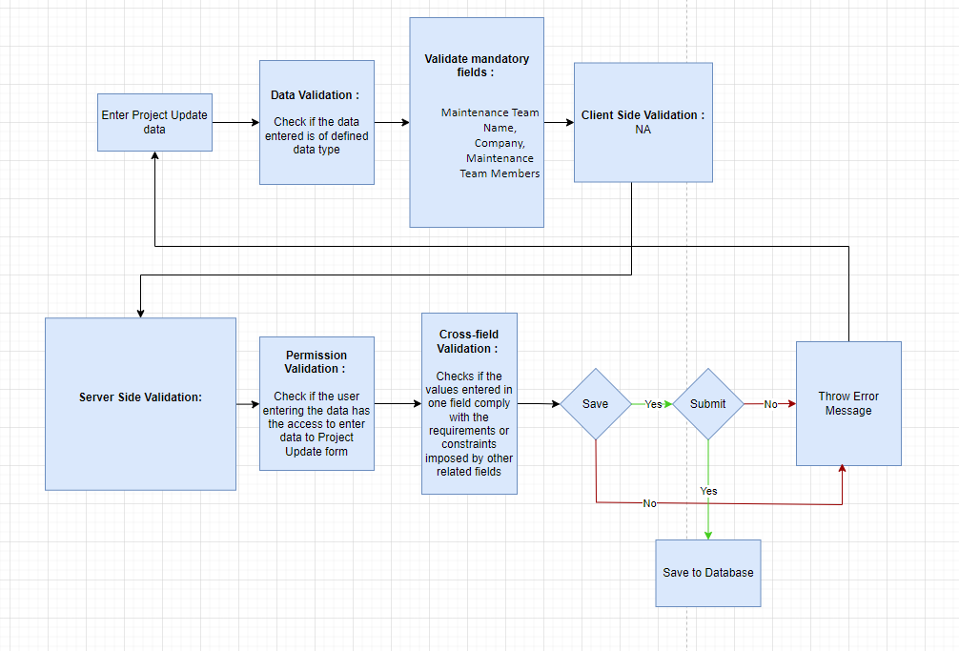

### Pre-requisites and Dependency

* Not Applicable

# Tools And Technologies

This section explains the tools that are used to build this design document

* Draw.io - it is an online tool used to develop the flowcharts used in this document.
* WPS office - it is a text editor that has been used to write and assemble this documents

# Non-Functional Requirements

## Performance

Specify performance requirements, including response times, transaction throughput, and system scalability

## Reliability

Define the reliability requirements, such as availability, fault tolerance, and disaster recovery

## Usability

Describe usability requirements, including user-friendly interfaces, clear error messages, and intuitive workflows

## Compatibility

Specify compatibility requirements with different operating systems, web browsers, and devices

## Security

Security requirements, including authentication, access control, data encryption, and secure communication protocols

## Compliance

Specify any legal or regulatory compliance requirements, such as GDPR, PCI DSS, or other industry-specific standards

## Documentation

Describe the documentation requirements, including user manuals, developer guides, and API documentation

## Security: User access and authorization

The screens and the data in them is made secure by creating roles with different permissions and then assigning those roles the appropriate users. For this screen following are the roles and their corresponding permissions:

### 

**Project**

|  |  |  |  |  |  |  |  |  |  |
| --- | --- | --- | --- | --- | --- | --- | --- | --- | --- |
| **ID** | **Role** | **Select** | **Read** | **Write** | **Create** | **Delete** | **Submit** | **Cancel** | **Amend** |
| 1 | Project Manager | Yes | Yes | Yes | Yes | Yes | NA | NA | NA |
| 2 | Employee | No | Yes | No | No | No | NA | NA | NA |

**Task**

|  |  |  |  |  |  |  |  |  |  |
| --- | --- | --- | --- | --- | --- | --- | --- | --- | --- |
| **ID** | **Role** | **Select** | **Read** | **Write** | **Create** | **Delete** | **Submit** | **Cancel** | **Amend** |
| 1 | Project Manager | Yes | Yes | Yes | Yes | Yes | NA | NA | NA |
| 2 | Employee | No | Yes | No | No | No | NA | NA | NA |

**Project Template**

|  |  |  |  |  |  |  |  |  |  |
| --- | --- | --- | --- | --- | --- | --- | --- | --- | --- |
| **ID** | **Role** | **Select** | **Read** | **Write** | **Create** | **Delete** | **Submit** | **Cancel** | **Amend** |
| 1 | Project Manager | Yes | Yes | Yes | Yes | Yes | NA | NA | NA |
| 2 | Employee | No | Yes | No | No | No | NA | NA | NA |

### 

**Project Type**

|  |  |  |  |  |  |  |  |  |  |
| --- | --- | --- | --- | --- | --- | --- | --- | --- | --- |
| **ID** | **Role** | **Select** | **Read** | **Write** | **Create** | **Delete** | **Submit** | **Cancel** | **Amend** |
| 1 | Project Manager | Yes | Yes | Yes | Yes | Yes | NA | NA | NA |
| 2 | Employee | No | Yes | No | No | No | NA | NA | NA |

**Issue**

|  |  |  |  |  |  |  |  |  |  |
| --- | --- | --- | --- | --- | --- | --- | --- | --- | --- |
| **ID** | **Role** | **Select** | **Read** | **Write** | **Create** | **Delete** | **Submit** | **Cancel** | **Amend** |
| 1 | Project Manager | Yes | Yes | Yes | Yes | Yes | NA | NA | NA |
| 2 | Employee | No | Yes | No | No | No | NA | NA | NA |

**Issue Type**

|  |  |  |  |  |  |  |  |  |  |
| --- | --- | --- | --- | --- | --- | --- | --- | --- | --- |
| **ID** | **Role** | **Select** | **Read** | **Write** | **Create** | **Delete** | **Submit** | **Cancel** | **Amend** |
| 1 | Project Manager | Yes | Yes | Yes | Yes | Yes | NA | NA | NA |
| 2 | Employee | No | Yes | No | No | No | NA | NA | NA |

**Project Update**

|  |  |  |  |  |  |  |  |  |  |
| --- | --- | --- | --- | --- | --- | --- | --- | --- | --- |
| **ID** | **Role** | **Select** | **Read** | **Write** | **Create** | **Delete** | **Submit** | **Cancel** | **Amend** |
| 1 | Project Manager | Yes | Yes | Yes | Yes | Yes | NA | NA | NA |
| 2 | Employee | No | Yes | No | No | No | NA | NA | NA |

**Prototype**

# Prototype

The screen samples that have been derived based on the requirements gathered from the users / SME’s of the **Project Plan Monitoring** module

## Project

Description: Project management is task-driven. You can create a Project and divide it into multiple Tasks.

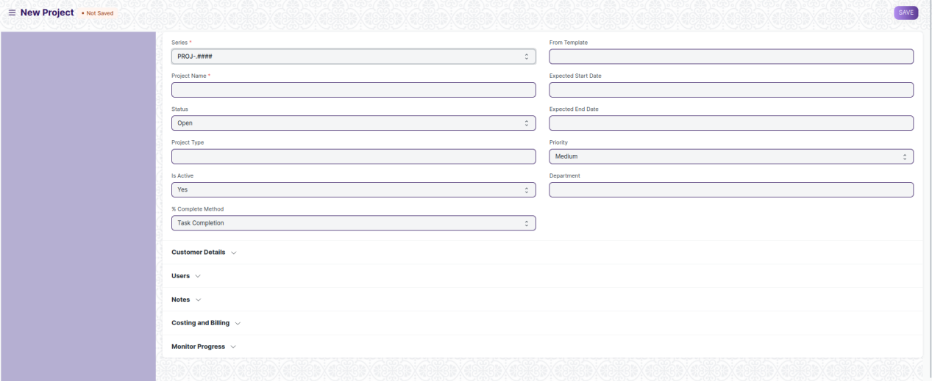

Figure : Project

## Task

Description: In project management, a task is an actionable unit or activity which needs to be completed. Whilst each task within a Project can be assigned to an individual or a group of individuals, the assignment can also be done at the project level

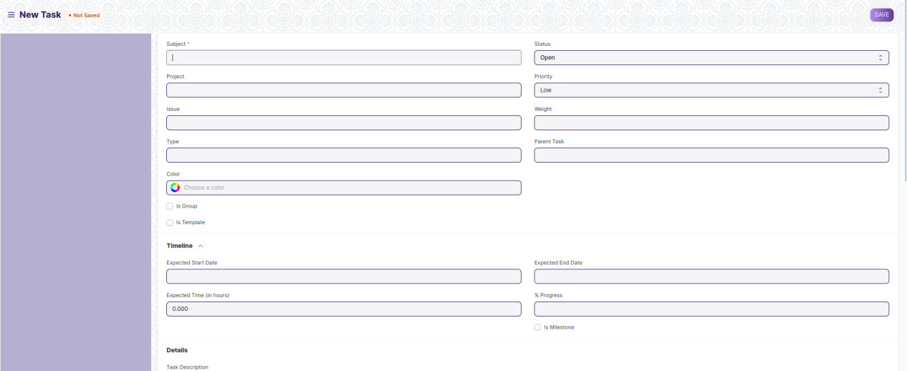

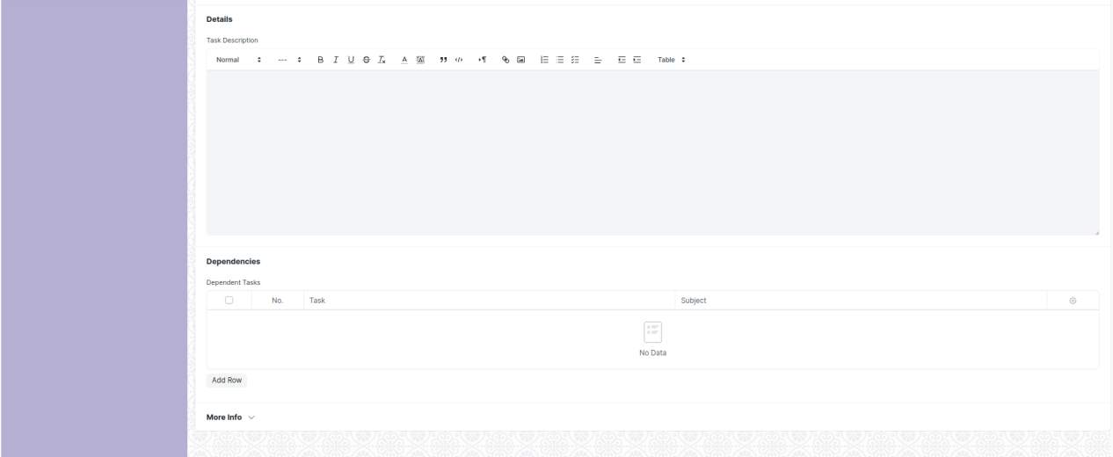

Figure: Task

## Project Template

Description: A Project Template is a predefined sequence of tasks arranged in stipulated schedule.

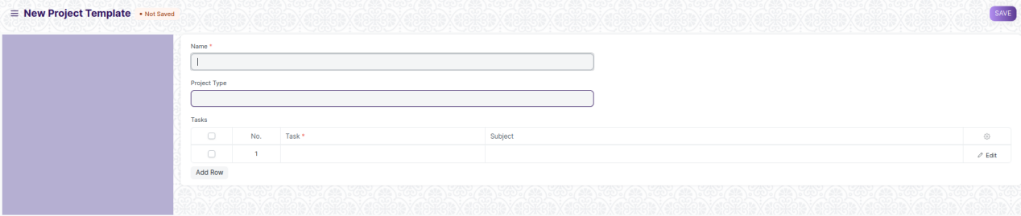

Figure : Project Template

## Project Type

Description: A Project Type is the classification of projects into different types to group similar kind of projects.

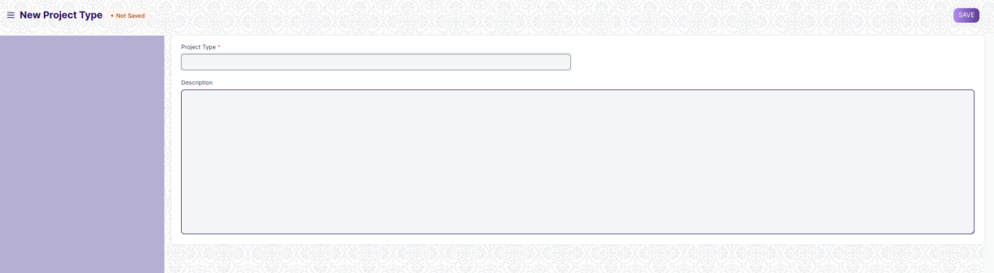

Figure : Project Type

## Issue

Description: This screen helps maintain issues which may come up in the project.

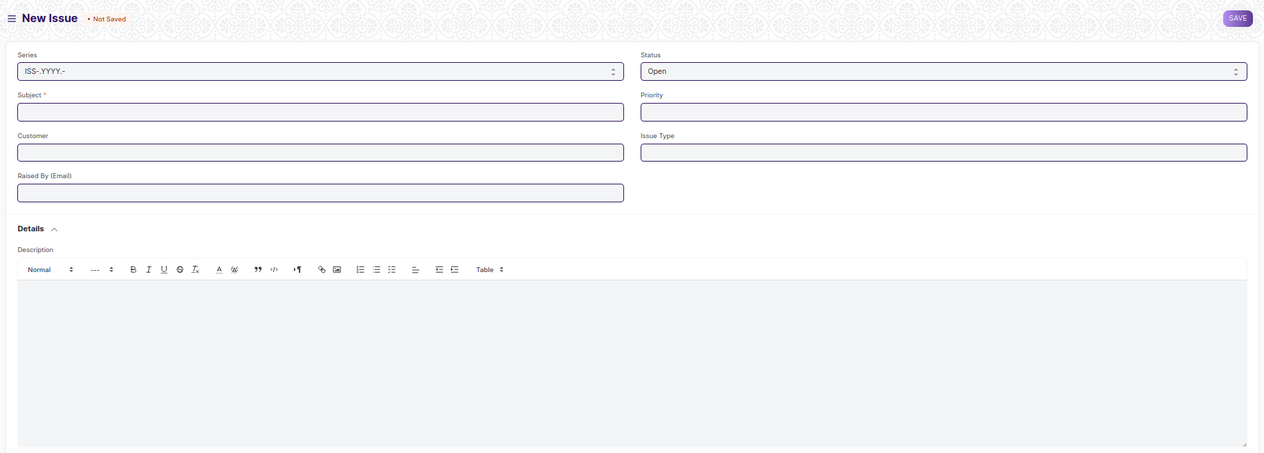

Figure: Issue

## Issue Type

Description: Issue Type is useful for tagging and classifying Issues.

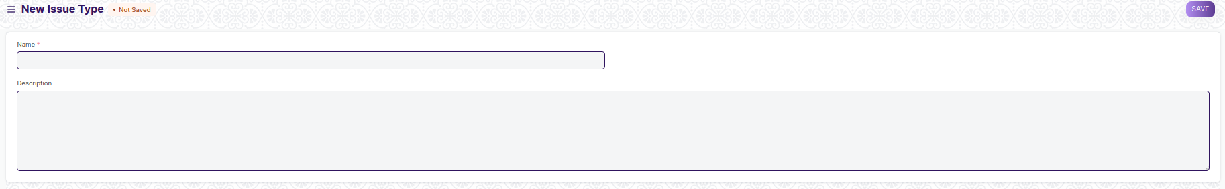

Figure : Issue Type

## Project Update

Description: A Project Update is the status of the Project which can be sent to all the stakeholders of the Project.

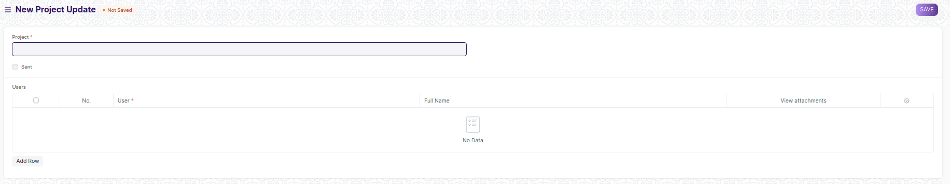

Figure: Project Update

# Definitions and Acronyms

The following table explains the terms and abbreviations used in the document:

|  |  |
| --- | --- |
| **Abbreviation** | **Description** |
| HLD | High Level Design |
| LLD | Low Level Design |
| API | Application Programming interface |
| NA | Not Applicable |
| ERP | Enterprise Resource Planning |
| HRMS | Human Resource Management System |
| GDPR | General Data Protection Regulation |
| PCI DSS | Payment Card Industry Data Security Standard |

# Deployment Description

* Application Name: Campus Management Application At World Skill Center (WSC)
* Deployment Environment: Production
* Server Information: IP address:117.250.67.19, domain name:erp.worldskillcenter.org, hosting provider: OCAC
* Deployment Date: 13-06-2023
* Database Information: MariaDB 10.6.*, Installed on the same server as the Application